

**Electrical & Computer Engineering Department**

**EE 6013: Topic in Smart Grid**

**Extended Reading List / Survey Report**

**Tolulope Olugbenga (Student ID: 3643581)**

**November 26th, 2019.**

# 1. The time series approach to short term load forecasting [1]

The paper reviews the application of time series analysis to load forecasting. It showed that Box and Jenkins time series models was more suitable for this application. One of the major drawbacks noted in this paper was the inability of the models to accurately represent the nonlinear relationship between the load and temperature. The authors suggested a procedure to overcome this drawback, and they compared several Box and Jenkins models with a forecasting procedure being used by a utility company. The paper was focused on short term load forecasts of one hour to a day ahead.

Section 2 of this paper shows the basic time series models and it also describes the evolution of the application of the models in load forecasting. The paper gave a description of the autoregressive (AR), moving average (MA), autoregressive-moving average (ARMA), autoregressive-integrated-moving average model (ARIMA), and the transfer function model (TRFU). The authors were able to circumvent the major drawback listed above by continuously updating the model parameters, which in turn relinearlized the model after each measurement. The transfer function model allows for addition of some independent variables such as the temperature. Further improvement was achieved by putting the temperature through a nonlinear transformation before feeding it in the transfer function model.

Section 3 described the procedures for developing, checking, and updating the Box and Jenkins models; it also compares the forecasting abilities of different models. The data was provided by a southwestern utility with 450,000 customers and a summer peak of about 3000MW. The authors were supplied an hourly net system loads and temperature readings from 1983 and 9 months of 1984. The 1983 data was used to develop ARIMA, TRFU, and nonlinear models for each season of the year. Four weeks of data was used to develop each model, and the models were used to forecast the following three weeks. In the case of the TRFU models, the actual temperatures were used in the load forecasts, this was because of the difficulty in obtaining temperature from the weather bureau.

The utility load forecasts for the 9 months of 1984 were provided. The 1983 ARIMA, TRFU, and nonlinear models that were developed on the 1983 data, were used for forecasting the 1984 data in order to compare them with the utility forecasts. Finally, 4 ARIMA and 4 TRFU models were created, one for each season in a year. Each model was used to forecast 24 hours load curves daily for a period of 3 weeks. The average percentage errors can be seen on the table below; from the table it is seen that the TRFU model provides a better prediction (on average) than the ARIMA model.

Section 4 presented a procedure that includes a nonlinear load-temperature model into the standard time series model. The authors noted that TRFU models do not accurately reflect the nonlinear relationship between the temperature and load; which leads to forecasting errors in the spring and fall seasons when there are wide temperature variations with small effects on the load. Their goal was to find a simple model for the load/temperature relationship and combine it with the TRFU model for forecasting. The table below shows a comparison of the results of the nonlinear method with the standard TRFU model, and the ARIMA model. The average over the four seasons, the ARIMA model had 4.2%, the TRFU model had 4.0%, and the nonlinear model had 3.74%.

Table :- The table shows a comparison of Mean Absolute Percentage Error for three different time series models (1983)

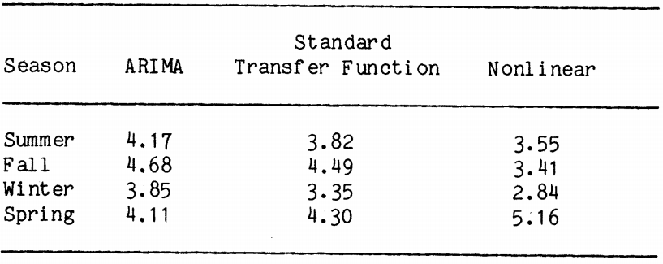

Section 5 describes the forecasting procedure and compares the accuracy of the utility’s forecasting with the ones the authors proposed. The time series model forecasts were compared with the conventional forecasts for three 20 day periods in 1984 (winter, spring, summer). The table below shows the mean absolute percent errors of the forecasts within each season. All the models did very well in predicting the 1984 loads as compared with the conventional forecasting method. The ARIMA model had a total average error of 4.92%, the TRFU model had 4.25%, the nonlinear model had 3.73%, and the conventional method had 5.75%. As compared to the conventional method; improvements of 14%, 26%, and 35% can be seen respectively. Among all the models, the nonlinear extension model was the best in predicting power loads.

Table :- The table shows a comparison of Mean Absolute Percentage Error for four different time series models (1984)

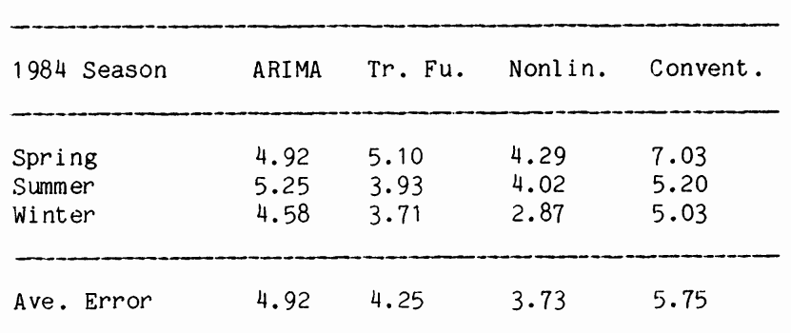

One of the major drawbacks of Box and Jenkins time series models is their inability to accurately describe the nonlinear relationship between load and temperature. The paper demonstrated that a simple polynomial regression analysis combined with the Box and Jenkins transfer function model improves the accuracy of forecasts. This nonlinear model was compared with the transfer function model, the periodic ARIMA, and a utility procedure which uses heavy dispatcher input. All of the Box and Jenkins models provided accurate forecasts, but the simple nonlinear extension to the transfer function model provided the best results.

# 2. Probabilistic electric load forecasting: A tutorial review [2]

The paper presents a tutorial review focused on probabilistic electric load forecasting (PLF) which includes; famous techniques, evaluation methods, and common misunderstandings. The authors presented the need for additional research in; reproducible case studies, probabilistic load forecast evaluation/valuation, and more consideration in emerging technologies/energy policies, in regards to the probabilistic load forecasting process. The authors highlighted the key features of different load forecasting problems, namely their temporal and spatial resolutions, forecast horizons, and output formats; the key features can be seen in the table below. The figure below shows the number of journal papers in the area of load forecasting since 1970s until when this paper was published; spatial load forecasting (SLF) and hierarchical load forecasting (HLF) was grouped together.

Table :- The table shows the key features of different load forecasting problems

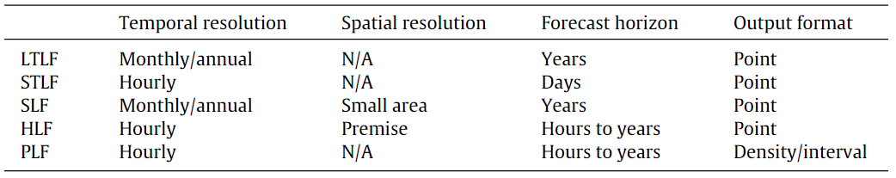

Figure :- The figure shows the number of journal papers in load forecasting since the 1970s

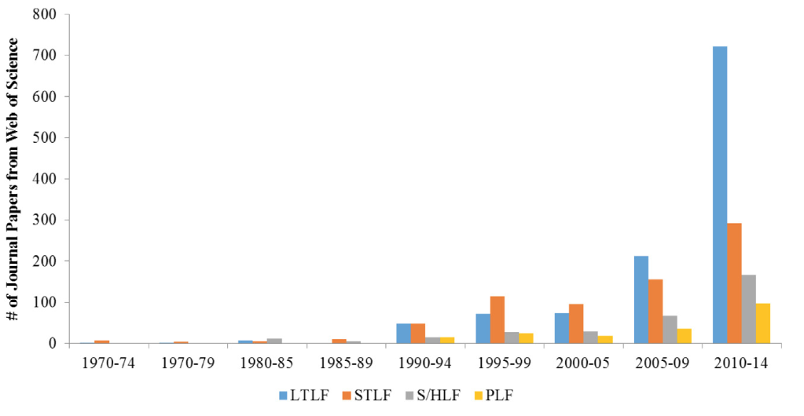

In the late 1990s to the early 2000s, there was more focus on short term load forecasting (STLF) than long term load forecasting (LTLF); this was due to the deregulation of the utility industry. The competition in the electricity markets demanded improvements in STLF, which led to a decrease in the need for LTLF. The deployment of the smart grid simulated the development in hierarchical load forecasting (HLF). Probabilistic load forecasting (PLF) has the lowest bar in all time periods but it showed an increasing trend in the last decade.

The paper contains lots of papers on load forecasting, but the authors noted that none of them was focused on probabilistic load forecasting (PLF). The paper shows a tutorial review devoted to PLF across all forecasting horizons. The authors began by reviewing several papers on point load forecasting; they noted that most PLF studies focused on the traditional point forecasting techniques. Progresses in PLF are made up of two groups; one from the application side, those who use load forecasts to meet business needs, and the other from the technical and methodological development side, those responsible for developing load forecast models. The paper reviewed major developments from each side. In the production and evaluation phase; the authors began by dissecting the PLF problem into three elements namely, the input, model and output. The authors noted that PLF forecast evaluation methods had not been fully developed at the time of writing of this paper. The authors discussed about the integration of PLF methods and techniques and they gave some recommendation for future research.

Section 3 of the paper discusses on load forecasting techniques and methodologies. The techniques highlighted are; multiple linear regression, semi-parametric additive models, exponential smoothing models, autoregressive moving average models, artificial neural networks, fuzzy regression models, support vector machine, gradient boosting. Section 4 discusses on the major developments of the application side and the technical/methodological development side. In the application side, the authors highlighted on; probabilistic load flow, unit commitment, and reliability planning. In the technical/methodological development side, the authors highlighted on; short term probabilistic load forecasting, long term probabilistic load forecasting, and interval forecasting without a probabilistic meaning. Section 5 discusses about the production and evaluation of probabilistic forecasts. Conventional point forecast metrics such as MAE and MAPE, can be used to evaluate the expected value of PLF at each iteration, the authors recommend it only for short term PLF. Sections 6 discusses several directions for future research.

The authors wanted to provide a tutorial review of probabilistic electric load forecasting as it’s a new branch of load forecasting. They wanted to offer some insights to researchers/practitioners in the area of load forecasting that could aid further development of useful models and methodologies. The authors noted that probabilistic load forecasting is an area that could take advantage of developments in multiple fields like statistics, electrical engineering, computer science, and meteorological science.

# 3. A methodology for electric power load forecasting [3]

The paper presents a pragmatic methodology that can be used as a guide in constructing electric power load forecasting (ELPF) models. The aim was to demonstrate a pragmatic ELPF methodology for analyzing the electric load pattern and forecasting the demand for short, medium, or long terms; it aims to forecast future load without a restriction on the term length (short, medium, or long). The methodology is based on the decomposition and segmentation of the load time series. The figure below shows a flowchart of the methodology.

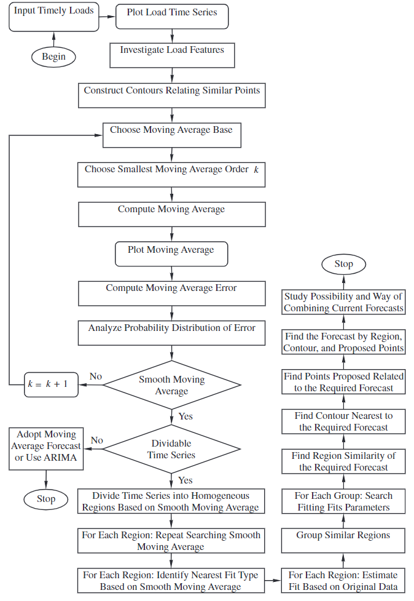

Figure :- The figure shows a flowchart of the proposed EPLF methodology.

The main phases of the methodology are; primal visual and descriptive statistical analysis, contour construction, load pattern decomposition, load pattern segmentation, future load forecasting. The first phase gives a primal conclusion about the behavior of the features of load time series. The second phase locates similar points along the time series around a single trend line, if it’s available. The load pattern decomposition is based on the noise superimposed on the main load component. The authors used the moving average method; the main component is expected to smooth. The smoothed moving average leaves a noise component with the smallest mean value and standard deviation greater than zero. The decomposition process was carried out for original time series and each homogenous region. The authors proposed that the moving average base could be a suitable measure of central tendency; but they warn that the order of the moving average should be chosen carefully.

The load pattern segmentation is based on the decomposition of original time series into two components to identify segments of time series. Each segment is identified by a set of points which demonstrate some homogeneity in the data. Future load forecasting can be achieved with the aid of the region similarity, the contour, and the proposed related points, and also by their combined forecast. A curve fitting is conducted on each region. The parameters of the resulting trends are studied to find if there is a correlation between the parameters of the regions; regions that have correlation between their parameters are assigned to a group. The effect of each region, contour, and proposed related point on the required forecast can be weighted; this means the process of estimating a forecast can be a weighted decision support system. The authors used the daily load data of Kuwaiti electric network from 2006 – 2008 as a case study; the figure below shows the time series of the load. They found from this case study that, each region can be used to forecast a daily future load by applying slight modification to the trend parameters.

Figure :- The figure shows the daily load in Kuwaiti network during 2006-2008.

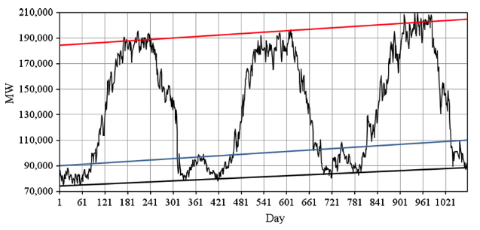

The paper reported that every electric network and plant needs its special forecasting because every country is indifferent in the factors that affect electricity demand. The paper proposes three bases; region similarity, contour, and proposed related points, and their combined forecasts. Forecasting analysis was conducted to the daily load time series of Kuwaiti electric network during three years. Their analysis proved that the proposed methodology works in this case study. The segmentation process resulted in homogeneous regions for which polynomial trends had been identified. The authors found that superimposed noise can be considered as normally distributed, this enables contrasting confidence intervals for future forecasts.

# References

[1] M. T. Hagan and S. M. Behr, “The Time Series Approach to Short Term Load Forecasting,” *IEEE Trans. Power Syst.*, vol. 2, no. 3, pp. 785–791, 1987.

[2] T. Hong and S. Fan, “Probabilistic electric load forecasting: A tutorial review,” *Int. J. Forecast.*, vol. 32, no. 3, pp. 914–938, Jul. 2016.

[3] E. Almeshaiei and H. Soltan, “A methodology for Electric Power Load Forecasting,” *Alexandria Eng. J.*, vol. 50, no. 2, pp. 137–144, 2011.

[4] H. K. Alfares and M. Nazeeruddin, “Electric load forecasting: Literature survey and classification of methods,” *Int. J. Syst. Sci.*, vol. 33, no. 1, pp. 23–34, Jan. 2002.

[5] I. Moghram and S. Rahman, “Analysis and evaluation of five short-term load forecasting techniques,” *IEEE Trans. Power Syst.*, vol. 4, no. 4, pp. 1484–1491, 1989.

[6] H. Hahn, S. Meyer-Nieberg, and S. Pickl, “Electric load forecasting methods: Tools for decision making,” *Eur. J. Oper. Res.*, vol. 199, no. 3, pp. 902–907, Dec. 2009.

[7] G. Gross and F. D. Galiana, “Short-Term Load Forecasting,” *Proc. IEEE*, vol. 75, no. 12, pp. 1558–1573, Dec. 1987.

[8] W. C. Hong, “Electric load forecasting by support vector model,” *Appl. Math. Model.*, vol. 33, no. 5, pp. 2444–2454, May 2009.

[9] R. Weron, *Modeling and forecasting electricity loads and prices: A statistical approach*. wiley, 2006.